New NZFSC fishing tournament
“Measure Champs”
Measure Champs
Measure Chaps is a 12 month catch and release tournament with awards for longest fish in selected species each month and an accumulated points section towards measure champs of the year.

The competition is open to all fishers and runs from April 3rd 2021 to April 3rd 2022.

Fishing classes: SENIOR, JUNIOR

  - Junior Age: 5 – 17 (17th birthday from April 3rd 2021 to April 3rd 2022 are eligible)

  - Seniors: 18 and up

Species: SNAPPER, KAHAWAI, KINGFISH, GURNARD, BLUE COD, TREVALLY, TROUT AND SALMON

Operations
- Entrants must pay the entry fee to be eligible for any prizes on offer.
- Entrants must download the NZSFC tournament application and use the app to record all catches.
- Each entry must be photographed using the ap with the fish on a commercially available measure mat clearly showing the length. (Standard measure rules apply from nose to v of the tail).
- NZSFC will report the winners of each section via the application.
- Winners will be promoted on all NZSFC media sites and appropriate sponsor sites when applicable.

Scoring System
Monthly
- 50 points per species caught
- 1 point per CM for the longest fish caught for each species per month. (You can register as many fish as you like during the month. Only the longest will receive points)
- Example. There are 8 species.
  - If an angler catches one of each species, they will achieve 8 x 50points = 400 points.
  - If the longest fish in each species is 50 centimetres, they will achieve 8 x 50 points = 400 points
  - Total points 800
  - If they catch the above every month the total points would be 12month * 800 points = 9,600 points
- The points are accumulated over 12 months to find the “NZSFC Measure Champ of the Year”, “Senior Measure Champ of the Year”, “Junior Measure Champ of the Year.”
Rules
Fishing parameters

- Fish must be caught on a handline or rod and reel
- Photograph of the fish on a measure mat must be uploaded in the app
- No nets
- No Contiki’s
- No grenades
- If unsure the catch is eligible refer to rule number 1.

Where applicable monthly prizes will be distributed the month following and the year end prizes will be distributed within 6 weeks of the tournament end date.

Entry Fee: $30 + .78 paypal fee.

Contact
As a competitor, you authorise, give permission for NZSFC and the competitions sponsors to use of any audio/visual imagery taken of yourself via photography, video content, drone footage and audio recordings, name, to be used for purposes of material produced for education, promotion, marketing or advertising for (included but not limited too) print, media releases, radio, TV, website, social media, graphics, editorials, banners, stickers, shirts, corflutes, street signs. Also, unless otherwise stated, there will be no restrictions on the geographical distribution of material produced.

NZSFC – New Zealand Sports Fishing Council
Prepare for the Event
Download the NZSFC App from Google Play or Apple App store.
If you have already downloaded the app, check for updates. NZSFC must be used in the most current update. Open a pop up will appear to allow notifications. Have you used any Track My Fish
or Infofish apps before?
→Yes – enter email / password and login
→No – click to sign up
If you get any pop ups advising invalid username or password or screen name not available, please contact secretary@nzsportfishing.org.nz to check your profile
Select the Group to Fish Under Press Enter
Select Record Catch – Click Select the event that you are fishing under
LOG YOUR CATCH | take a clear photo of the fish on the measure board. Make sure that the photo is clear on the mat and you can see the nose and tail in full. Take a second photo or video of you holding your catch or a fun pic of you & your team with the catch. This is referred to your GLORY PHOTO/VIDEO
DATA DETAILS |
→ Type the angler’s name in who caught the fish → Select the species → Choose the fishing category
→ Enter the length in mm
→ Comments - optional → Click Submit
NZSFC – New Zealand Sports Fishing Council
OTHER APP DETAILS
PHOTOSTREAM | make sure the photo stream button at the top of the screen is ON (set to green). This enables your photos to save to your phone on the phone gallery as well as upload into the application after submitting.
OFFLINE MODE | turn your phone to offline mode. This saves your battery power and use in low mobile reception. To go offline, click the green button:
You will still be able to use the app to log your catches. Once back in range or at the boat ramp, if you have a minimum of 3-bars of 3G mobile reception, turn this back on to submit what you have caught.
STOP | When pressed this will take you back to the main page of the app
Frequently Answered Questions (FAQ’s)
What is a Glory Photo? This is a photo of you holding your fish or a 30 secs video, of you and your team with the fish.
How can I see if my fish score is submitted?
When you open the in the catch screen app, in the top left of the screen is a LOG button.
The list of all the fish will show that you have logged. Under each log will show if the data & image has been received. For example:
If it reads green RECEIVED, it means the data AND the image has been received to the score checker
If it reads red NOT SENT it means neither the data or image has been sent and therefore not received.
If it reads orange IMAGE NOT SENT it means the data has been received (fisher, length, type etc) but the image has not been received.
If you have either the red or orange, you will need press the SUBMIT ALL button so its re-uploads. Please keep checking until all your logs show green. Also check your phone reception to make sure it’s good before trying to submit again.
Where can I find the scoreboard?
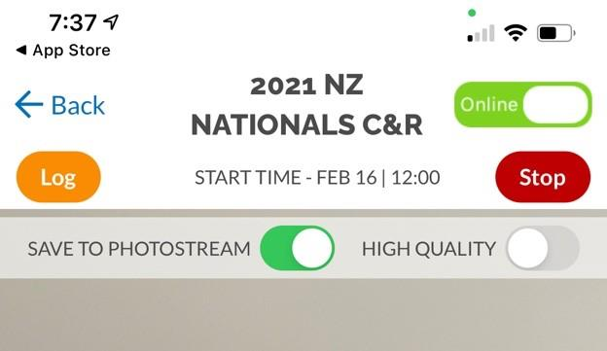
If you are wanting to check the scoreboard, click the information screen then scoreboard & the event you would like to see.
Where can I find the scorecard?
In the information screen, click scorecard, here you will see the status of your entries
If you see ACCEPTED IMAGE RECEIVED next to the entry, it is the confirmation that the fish and therefore your score for that fish in the server have been accepted i.e. no discrepancies in your scoring.
If you see SUBMITTED IMAGE RECEIVED, it means the data and image have been received but the official scorechecker is yet to verify and accept your entry. This simply means the data is still to be
checked.
If you see SUBMITTED IMAGE NOT RECEIVED, it means the data has been received but not the image. Go to the LOG page in the previous question and follow the resubmission steps.
If a submission is missing, it’s either been rejected (the score does not count due to breach of rules) or nothing at all has been received. If your submission is missing, go back to your log (see previous question) and check your data has been upload. If it is showing as green RECEIVED and the submission is not in the CHECK MY SCORE, your fish has been rejected.
NOTE - in any issue of the above, please do not resubmit data or a fish. If you have queries, please come make contact with a Track My Fish team member.
NOTE – if you submit an incorrect size or species or assign to the incorrect angler please do not resubmit your data or fish. If this occurs, please make contact with a Track My Fish team member.

